Android Developer Bootcamp

Student Profile Page

Workshop #02

🎯 Purpose
This workshop helps you practice designing a student profile page using XML layouts in Android.
You will learn how to use ScrollView, FrameLayout, TableLayout, TextView, ImageView, and Button components to create an attractive profile interface.

🧩 Problem
Design a Student Profile Page UI in Android using XML.

📚 Student Information
Below the profile header, create a TableLayout displaying the following information:
Field | Value
Name | Riyana
Roll No | 101
Course | Android Development
Email | riyana@email.com
Phone | 9876543210

📚 Actions
Below the table, add two buttons:
- Edit Profile
- Save Changes
Arrange the buttons horizontally.

How to Solve
Checkout the workshop from Git Repo:
git clone -b <user-branch> <repo-URL>
- Open the root folder inside Android Studio.
- Create the layout using XML only.
- Use ScrollView as the parent layout.
- Use TableLayout and TableRow for displaying student details.
- Add buttons for profile actions.
- Run the application on an emulator or Android device.

🎯 You Will Achieve
After completing this workshop, you will understand:
- How to use ScrollView in Android.
- How to create layered layouts using FrameLayout.
- How to display structured information using TableLayout.
- How to use TableRow for organizing data.
- How to create a simple student profile interface.
- How to apply spacing, colors, and styling to improve UI design.

📸 Screenshots

Before Implementation
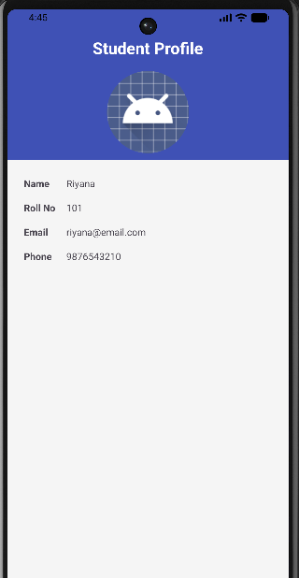

After Implementation
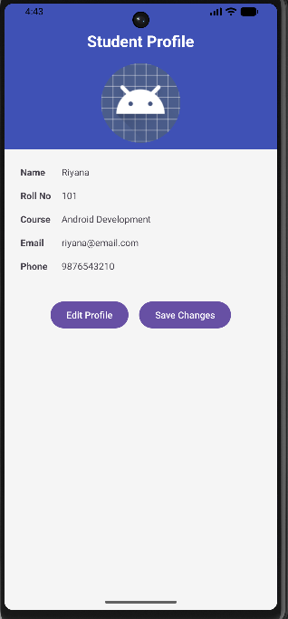

How to Submit Your Workshop
Push your project back to the same Git branch using:
git add .
git commit -m "Completed Student Profile Page Workshop"
git push origin <user-branch>

🚀 Happy Coding! 🎨📱

